Programming for the Web HSC Assessment Task 1

Group Name: HOT PINK

Group Members:
PETER TRINH
AN TRAN
HENRY PHAM

Git Hub: Link to the Code Repository

Contents
Project Documentation 3
Team Contribution: 3
Gantt Chart 4
Git Hub Log 5
Copyright Acknowledgement 6
Software Solutions 7
Purpose of the High-Level Design 8
Purpose of the Low Level Design 9
Class Diagram of the Project and Interaction between Classes 10
Tree Structure 12
Deploying the project 14
Justification of Deploying the project in the cloud. 15
Justification of code made to the Project if made? 16
Make sure the code is commented in a ratio of 3:1, three lines of code to one line of comments. 16
Code Structure 19
Project Presentation 23
Appendix 24
Code is pasted in a white font! 24

Project Documentation

Team Contribution:

Peter: Documentation
Henry: Coding + Database
An: Diagrams + Project Presentation

Gantt Chart
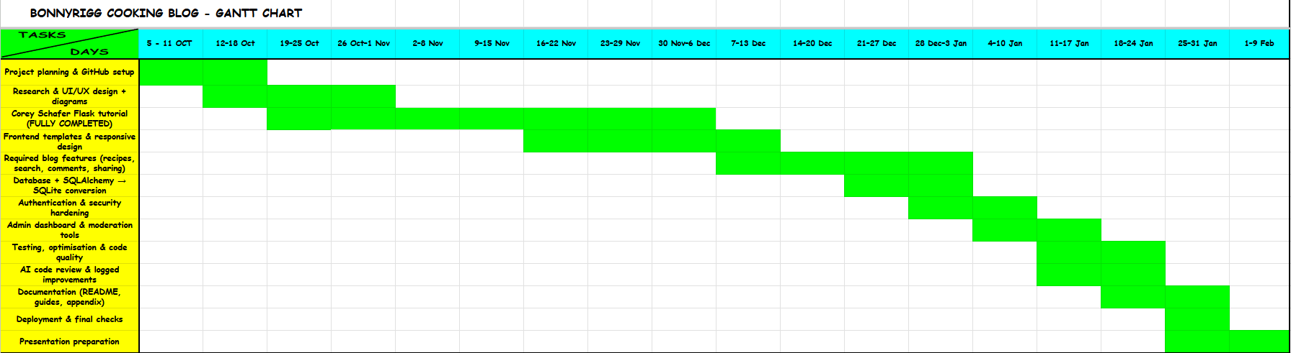

Git Hub Log
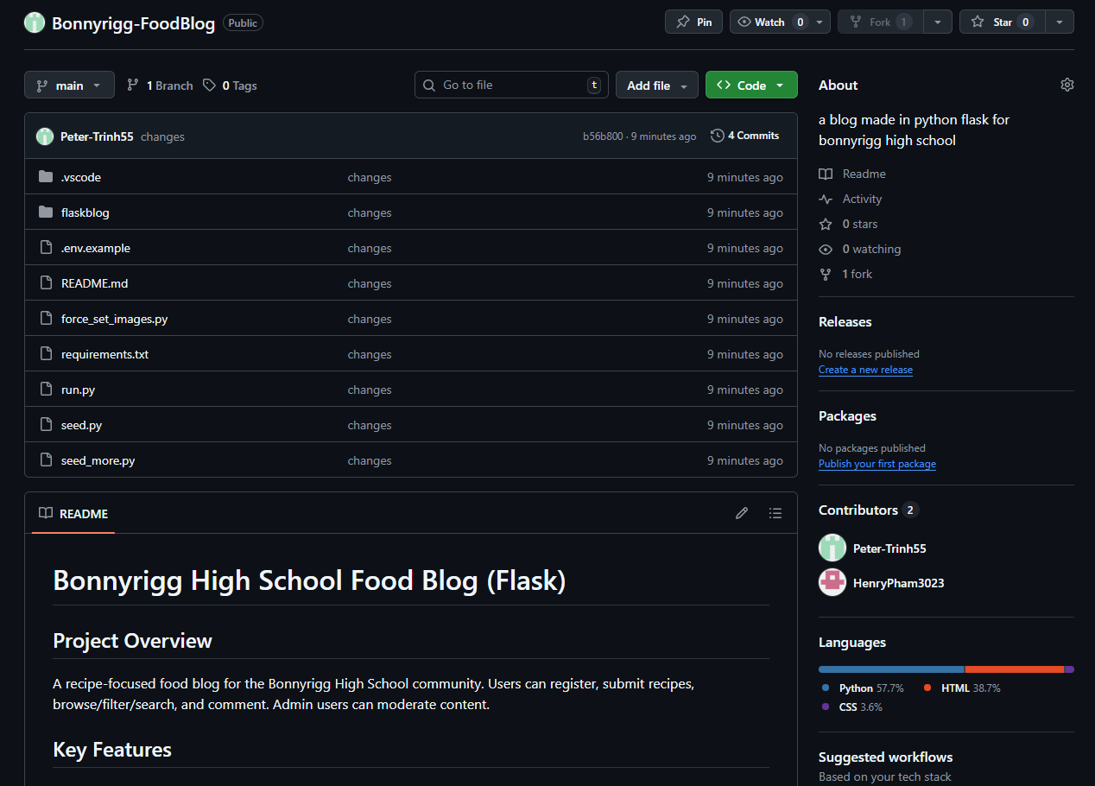

Copyright Acknowledgement

This project, Bonnyrigg Cooking Blog, was developed as part of the HSC Software Engineering – Programming for the Web assessment task. All work submitted is original unless otherwise stated, and any external resources, tools, or references used during the planning, development, and evaluation of this project have been appropriately acknowledged below.
The core structure and foundational concepts of the Flask web application were informed by Corey Schafer’s Flask Tutorial Series (YouTube). This tutorial was used strictly as a learning resource to understand Flask application structure, routing, templates, authentication patterns, and database interactions. All code implemented in this project was written, adapted, and extended by the students to meet the specific assessment requirements and project objectives.
The Flask Framework (Python) was used as the primary backend web framework for routing, request handling, and application logic. Flask is an open-source framework distributed under the BSD License and was used in accordance with its licensing terms.
Database functionality was implemented using SQLAlchemy, an open-source Object Relational Mapper (ORM) for Python and later modified to use SQLite as required by the assessment task. SQLAlchemy and SQLite are open-source technologies and were used to manage persistent storage of users, recipes, and comments.
Artificial Intelligence tools, including ChatGPT (OpenAI) and GitHub Copilot, were used as supportive development tools to assist with code review, debugging suggestions, optimisation ideas, and general programming guidance. All AI-generated suggestions were critically analysed, modified where necessary, and manually implemented by the students. Improvements informed by AI tools were logged through the GitHub repository and documented in the project documentation in accordance with assessment requirements.
Additional tools and resources used in this project include:
- GitHub for version control and evidence of incremental development
- Visual Studio Code / PyCharm as the integrated development environment (IDE)
- HTML5, CSS3, and JavaScript for frontend development
- Figma for UI/UX wireframing and prototyping

Software Solutions

The Bonnyrigg Cooking Blog is a full-stack web application developed using the Flask framework. The solution was designed to provide a functional, secure, and engaging platform where users can explore cooking recipes, read blog posts, and interact with community content.
The frontend of the application was developed using HTML5, CSS3, and JavaScript, creating a clean and responsive user interface. The design allows users to easily navigate the website, browse featured recipes, view detailed recipe pages containing ingredients and step-by-step instructions, and interact with blog content across both desktop and mobile devices.
The backend was implemented using Python and Flask, which manages application routing, form handling, authentication, and server-side logic. Flask was selected due to its lightweight architecture and flexibility, making it suitable for this type of web application. Application logic is organised into structured routes and models to improve readability and maintainability.
Data persistence is handled using SQLAlchemy, an Object Relational Mapper (ORM), with the database modified to use SQLite as required by the assessment task. The database stores users, recipes, blog posts, and comments, with relationships defined between tables to ensure data consistency and integrity.
Security considerations were incorporated throughout development. These include input validation to prevent invalid or malicious data, secure password hashing for user accounts, session management for authenticated users, and error handling to ensure system stability. An administrative dashboard was also implemented to allow authorised users to manage content, edit or delete recipes, and moderate user comments.
Testing was conducted to verify that all core features function as intended and meet the project requirements. Overall, the software solution demonstrates effective use of web technologies, structured programming practices, and secure development principles to deliver a reliable and user-friendly web application.

Purpose of the High-Level Design

The purpose of the High-Level Design (HLD) is to provide an overall view of how the Bonnyrigg Cooking Blog system is structured and how its main components interact. The high-level design focuses on the system architecture rather than detailed implementation, allowing the project to be planned and developed in a logical and organised manner.
The high-level design outlines the separation between the frontend, backend, and database layers of the application. The front-end is responsible for user interaction and presentation, the backend handles application logic and request processing using the Flask framework, and the database layer manages persistent data storage using SQLAlchemy and SQLite. This clear separation of responsibilities improves maintainability and scalability.
The high-level design also identifies the core system components, including user authentication, recipe management, blog content, comments, and administrative functionality. By defining these components early in the project, development tasks could be allocated effectively and dependencies between system features were clearly understood.
Overall, the high-level design acts as a blueprint for the project, guiding development decisions and ensuring that the final software solution meets the functional, security, and performance requirements of the assessment task.

Purpose of the Low-Level Design

The purpose of the Low-Level Design (LLD) is to describe how the individual components of the Bonnyrigg Cooking Blog system are implemented in detail. While the high-level design focuses on the overall system architecture, the low-level design concentrates on the internal logic, structure, and behaviour of specific modules within the application.
The low-level design outlines how Flask routes, functions, and database models operate and interact. This includes defining how user requests are processed, how data is validated and stored, and how responses are returned to the frontend. It also details the structure of database models, relationships between tables, and how CRUD (Create, Read, Update, Delete) operations are handled within the application.
By documenting the low-level design, the project ensures that code is modular, readable, and maintainable. Each function and module has a clearly defined responsibility, making the system easier to test, debug, and extend. This design approach also supports secure programming practices by clearly identifying where authentication, session management, and error handling are implemented.
Overall, the low-level design provides a detailed blueprint for implementation, ensuring that the software solution is built consistently, efficiently, and aligned with the project requirements and assessment criteria.
Example of low – level design = PSEUDOCODE:
BEGIN BONNYRIGG PIZZA BLOG SYSTEM

INITIALISE Flask application
INITIALISE SQLite database
SET secret key for secure sessions
CONFIGURE upload folder for profile images
CONFIGURE secure cookie settings

CREATE User table
STORE user_id
STORE username
STORE email
STORE hashed_password
STORE admin_status
STORE profile_image
STORE two_factor_enabled
STORE two_factor_secret
STORE email_verification_code
STORE code_expiry

CREATE Recipe table
STORE recipe_id
STORE title
STORE pizza_type
STORE difficulty
STORE cook_time
STORE description
STORE ingredients
STORE steps
STORE image_filename
STORE date_created

CREATE Comment table
STORE comment_id
STORE recipe_id
STORE author_name
STORE comment_text
STORE date_created

--------------------------------------------------
MAIN HOME PAGE PROCESS
--------------------------------------------------
DISPLAY all pizza recipes

IF user enters search text THEN
SEARCH recipe title
SEARCH recipe description
SEARCH recipe ingredients
END IF

IF user selects pizza type THEN
FILTER recipes by pizza type
END IF

IF user selects difficulty THEN
FILTER recipes by difficulty
END IF

SHOW matching recipes on homepage

--------------------------------------------------
REGISTER ACCOUNT PROCESS
--------------------------------------------------
INPUT username
INPUT email
INPUT password

IF any field is empty THEN
SHOW error message
STOP
END IF

IF email already exists in database THEN
SHOW error message
STOP
END IF

HASH password
GENERATE authenticator secret
SAVE new user to database
SHOW registration success message

--------------------------------------------------
LOGIN PROCESS
--------------------------------------------------
INPUT email
INPUT password

FIND matching user in database

IF user not found OR password incorrect THEN
SHOW login error
STOP
END IF

IF two_factor_enabled = FALSE THEN
START user session
REDIRECT to homepage or admin dashboard
ELSE
ASK user to choose verification method
OPTION 1 = email code
OPTION 2 = authenticator app

IF email code selected THEN
GENERATE 6 digit code
SAVE code and expiry time
SEND code by Gmail
ASK user to enter 6 digit code

IF code is correct AND not expired THEN
START user session
REDIRECT to homepage or admin dashboard
ELSE
SHOW verification error
END IF
END IF

IF authenticator selected THEN
ASK user to enter authenticator code
VERIFY code using TOTP secret

IF authenticator code is correct THEN
START user session
REDIRECT to homepage or admin dashboard
ELSE
SHOW verification error
END IF
END IF
END IF

--------------------------------------------------
PROFILE PAGE PROCESS
--------------------------------------------------
CHECK user is logged in

DISPLAY current username
DISPLAY current profile image
DISPLAY 2FA status

IF user updates username THEN
VALIDATE input
SAVE new username
END IF

IF user uploads profile image THEN
CHECK file type is png, jpg, jpeg, or gif
RENAME file safely
SAVE file to uploads folder
UPDATE database with new filename
END IF

IF user changes password THEN
INPUT new password
INPUT confirm password

IF passwords do not match THEN
SHOW error
STOP
END IF

HASH new password
SAVE updated password
END IF

IF user enables authenticator 2FA THEN
GENERATE secret key if missing
SAVE secret key
DISPLAY secret key for authenticator app setup
END IF

SHOW success message

--------------------------------------------------
FORGOT PASSWORD PROCESS
--------------------------------------------------
INPUT email

IF email not found THEN
SHOW error message
STOP
END IF

ASK user to choose verification method

IF authenticator 2FA is enabled THEN
ALLOW authenticator method
ELSE
USE email verification method
END IF

IF email verification method chosen THEN
GENERATE 6 digit code
SAVE code and expiry time
SEND code by Gmail
ASK user to enter code

IF code correct AND not expired THEN
ALLOW user to continue
ELSE
SHOW verification error
STOP
END IF
END IF

IF authenticator verification chosen THEN
ASK user to enter authenticator code

IF code is valid THEN
ALLOW user to continue
ELSE
SHOW verification error
STOP
END IF
END IF

INPUT new password
INPUT confirm password

IF passwords match THEN
HASH new password
SAVE to database
CLEAR reset token and verification code
SHOW password reset success message
ELSE
SHOW password mismatch error
END IF

--------------------------------------------------
ADMIN DASHBOARD PROCESS
--------------------------------------------------
CHECK if logged in user is admin

IF user is not admin THEN
SHOW access denied
REDIRECT to login page
STOP
END IF

DISPLAY all recipes
DISPLAY number of users
DISPLAY number of comments

IF admin submits new recipe THEN
INPUT title
INPUT pizza type
INPUT difficulty
INPUT cook time
INPUT image filename
INPUT description
INPUT ingredients
INPUT steps

IF any required field is missing THEN
SHOW validation error
STOP
END IF

SAVE new recipe to database
SHOW success message
END IF

--------------------------------------------------
RECIPE PAGE PROCESS
--------------------------------------------------
DISPLAY recipe image
DISPLAY title
DISPLAY pizza type
DISPLAY difficulty
DISPLAY cook time
DISPLAY description
DISPLAY ingredients list
DISPLAY step-by-step method
DISPLAY all comments

IF user submits comment THEN
INPUT author name
INPUT comment text

IF any comment field is empty THEN
SHOW error
STOP
END IF

SAVE comment to database
REFRESH recipe page
END IF

--------------------------------------------------
SECURITY PROCESS
--------------------------------------------------
USE hashed passwords for all users
USE session management for logged in users
USE input validation on forms
USE safe file type checking for uploads
USE 2FA for extra authentication
USE expiry times for email verification codes
RESTRICT admin pages to admin users only
SHOW graceful error messages without exposing system details

END BONNYRIGG PIZZA BLOG SYSTEM

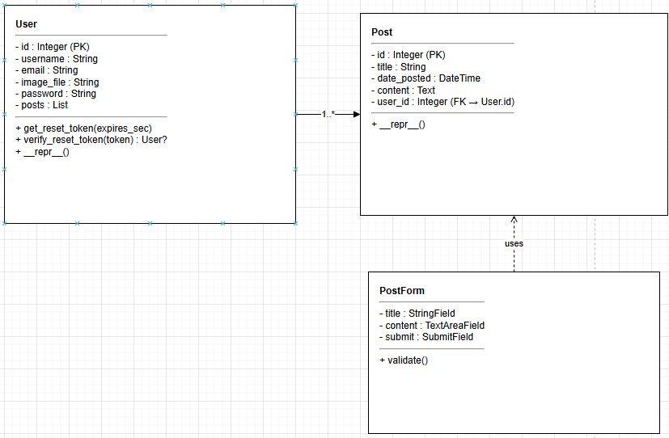
Class Diagram of the Project and Interaction between Classes

The class diagram represents the structural design of the Bonnyrigg Cooking Blog application and illustrates how the system’s core classes interact.
The primary classes identified in the system are User, Post, and PostForm. The User and Post classes inherit from db.Model, meaning they represent database tables managed through SQLAlchemy. The PostForm class inherits from FlaskForm, representing structured user input for creating blog posts.
The most significant relationship in the system exists between the User and Post classes. This relationship is defined as one-to-many, where one user can create multiple posts. This is implemented through a foreign key (user_id) in the Post class and a relationship field (posts) in the User class. This design ensures referential integrity and allows efficient querying of posts by a specific user.
The PostForm class interacts with the Post model by collecting validated user input and passing it to the backend logic for storage in the database. While it does not directly store data, it facilitates structured and secure data entry.
Additionally, system-level components such as SQLAlchemy, LoginManager, Bcrypt, and Mail are initialised in the application factory (create_app()), demonstrating separation of concerns and modular application architecture.
Overall, the class structure demonstrates clear modularisation, defined relationships, and adherence to object-oriented programming principles, supporting maintainability and scalability of the application.

Tree Structure
Tree structure annotated as shown in the video. Take a snapshot of it using the Snipping Tool.
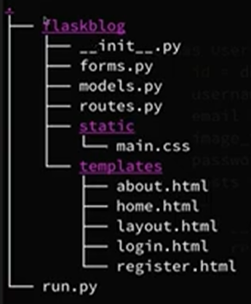

The tree structure of the Bonnyrigg Cooking Blog project defines how the application is organised into logical components, separating backend logic, frontend presentation, and static assets. This structure improves readability, maintainability, and scalability of the codebase.
At the root level of the project, the run.py file acts as the entry point of the application. This file is responsible for starting the Flask development server and running the application.
The flask blog directory is the main application package. It contains all backend and front-end related components required for the system to function.
Within the flask blog package:
- __init__.py
This file initialises the Flask application. It creates the Flask app instance, configures settings, and links together components such as the database and routes. This allows the application to be imported and run as a package.

- routes.py
This file defines the application routes. Routes handle incoming HTTP requests and determine which logic is executed and which HTML templates are rendered. It acts as the controller that connects user actions to backend processing.
- models.py
This file defines the database models using SQLAlchemy. It represents database tables such as users, recipes, and posts as Python classes, allowing structured interaction with the database.
- forms.py
This file contains form classes used for user input, such as login, registration, and content submission forms. It supports input validation and ensures secure handling of user data.
The static folder stores static frontend assets that do not change dynamically. In this project, it includes:
- main.css, which controls the visual styling, layout, and responsiveness of the website.
The templates folder contains HTML templates used to render pages displayed to the user. These templates use Jinja templating to dynamically insert content from the backend. Examples include:
- layout.html – the base template that defines the overall page structure
- home.html – the homepage content
- about.html, login.html, and register.html – pages for navigation and user interaction
This separation of concerns between routes, models, forms, templates, and static files ensures that frontend and backend responsibilities are clearly defined. The tree structure follows best practices demonstrated in Corey Schafer’s Flask tutorial and supports modular, secure, and maintainable web application development.

Deploying the project
Carefully explain how to deploy the project.

Justification of Deploying the project in the cloud.

Deploying the Bonnyrigg Cooking Blog in the cloud provides several advantages compared to running the application solely on a local machine. Cloud deployment allows the application to be accessed remotely through the internet, making it available to multiple users at the same time without requiring access to the developer’s local environment.
Cloud platforms offer improved availability and scalability, allowing the application to handle increased user traffic if required. As usage grows, cloud resources such as processing power and storage can be adjusted without major changes to the application code. This makes cloud deployment suitable for web applications designed for community interaction.
From a maintenance and reliability perspective, cloud services provide consistent runtime environments, automatic updates, and improved system stability. This reduces the risk of hardware failure and ensures the application remains accessible and operational.
Cloud deployment also supports modern software engineering practices, including version control integration, continuous deployment, and collaborative development. When combined with platforms such as GitHub, changes can be tracked, tested, and deployed efficiently.
Although this project was primarily deployed on localhost for development and assessment purposes, the application architecture using Flask and SQLite is compatible with cloud platforms. This demonstrates an understanding of current software and hardware technologies and reflects real-world web development practices.

Justification of code made to the Project if made?

Make sure the code is commented in a ratio of 3:1, three lines of code to one line of comments

Justification of Code Made to the Project (If made)
Throughout development of the Bonnyrigg Cooking Blog System, several enhancements were implemented beyond the base tutorial functionality to improve usability, performance, security, maintainability, and overall user experience. The following justifies these code modifications and design decisions.

1. Cuisine-Based Tabs (Italian, Asian, Mexican, etc.)
Cuisine categorisation was added to allow recipes to be filtered by type.
Justification:
- Improves logical organisation of data within the system.
- Enhances database structure by introducing structured classification.
- Allows efficient retrieval of recipes through filtered queries.
- Increases scalability, as new cuisine categories can be added without restructuring the system.
This change strengthens the overall data modelling and structural design of the application.

2. UI and User-Friendly Improvements
User interface enhancements were implemented through layout redesign and improved visual structure.
Justification:
- Improves clarity and ease of navigation.
- Makes the system more visually engaging and professional.
- Enhances accessibility and readability for a wider audience.
- Creates a more intuitive flow between user and system.
These changes focus specifically on improving user experience and presentation quality.

3. Performance Improvements (Reducing Lag on Launch)
Code optimisations were introduced to improve efficiency during application startup and page loading.
Justification:
- Reduces unnecessary database queries.
- Improves processing efficiency.
- Minimises initial load time.
- Enhance responsiveness as data volume increases.
These improvements strengthen the technical efficiency and scalability of the system.

4. Password Reset and Database Security Enhancements
Additional authentication and database handling features were implemented.
Justification:
- Strengthens security through controlled verification mechanisms.
- Protects user credentials and sensitive data.
- Improves data integrity within the database.
- Ensures secure handling of account-related operations.
These changes focus specifically on improving system security and reliability.
5. Consistent Commenting at a 3:1 Ratio
A structured commenting standard was applied across the entire codebase.
Justification:
- Improves readability and understanding of complex logic.
- Supports collaborative development.
- Simplifies debugging and future maintenance.
- Demonstrates professional documentation practices.
This modification enhances maintainability and long-term sustainability of the system.

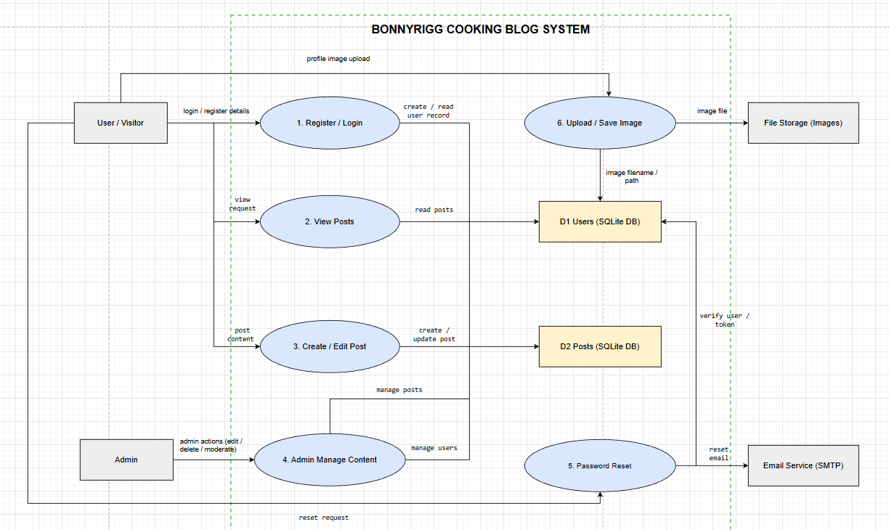
Code Structure

Overall architecture
The Bonnyrigg Cooking Blog System is structured using a modular Flask architecture so each file has a clear responsibility (maintainability + readability). This directly targets the marking criteria focus on code readability, consistency, comments, and modularisation, plus having Data Flow Diagrams and related design artefacts.
How the system is organised
The project follows the typical Flask “app package” structure:
- Application entry point
  - run.py: starts the Flask server and runs the application.
- Application package (backend)
  - __init__.py: application factory / setup (creates the Flask app, loads config, initialises extensions such as database + login/session components).
  - models.py: database table definitions (e.g., User, Post) and their relationships.
  - forms.py: all input forms and validation rules (e.g., login/register forms, post form, reset password form).
  - utils.py: helper functions that support features like image processing and password-reset email sending.
- Routes / Controllers
  - routes.py (or split routes such as users/routes.py, posts/routes.py): handles URL endpoints, reads user input, calls models/forms/utils, and returns the correct template.
- Frontend
  - templates/: HTML templates (pages such as home, about, login, register, account/profile, create/edit post).
  - static/: CSS, JavaScript, and images (site styling and client-side behaviour).

Mapping your Data Flow Diagram to code modules (control flow)
Your final DFD shows the system’s major processes and data stores (Users DB and Posts DB), plus external services (Image storage and Email service). In the code, those flows map like this:
- Register / Login (DFD Process 1)
- forms.py validates user input (email, username, password).
- models.py writes/reads users from D1 Users (SQLite DB).
- routes controls the sequence: show form → validate → authenticate → create session.
- View Posts (DFD Process 2)
- routes handles requests to view posts.
- models.py queries D2 Posts (SQLite DB).
- templates render posts to the browser.
- Create / Edit Post (DFD Process 3)
- forms.py validates title/content inputs.
- models.py saves/updates records in D2 Posts.
- routes ensures only authorised users can create/edit.
- Admin Manage Content (DFD Process 4)
- routes enforces authorisation checks (admin-only operations).
- Uses models.py to manage D1 Users and D2 Posts (edit/delete/moderate).
- Password Reset (DFD Process 5)
- forms.py validates reset request input.
- models.py checks D1 Users (verify user/token).
- utils.py communicates with Email Service (SMTP) for reset emails.
- Upload / Save Image (DFD Process 6)
- utils.py processes/saves image files to File Storage (Images).
- The resulting filename/path is stored back into D1 Users (profile image reference).

Secure and safe coding practices in the structure
To align with the software-solution marking criteria, the structure supports:
- Input validation in forms.py (server-side validation rather than trusting the browser).
- Secure authentication + session management handled through the login/session components initialised in __init__.py and enforced in routes.
- Error handling and robustness by centralising tricky operations (file upload, email sending) in utils.py so errors can be caught and handled consistently.

Readability, maintainability, and documentation
To meet the “code structure” expectations at a high level:
- Follow consistent naming + indentation (PEP8 style).
- Keep functions short and single-purpose (routes call helpers instead of doing everything inline).
- Ensure comments are present and meaningful (explain why not just what).
These are all directly listed in the code-structure marking points.

Project Presentation
- Google Slide
- Explain what the project is about
- Explain the various technologies and Tools used in the project and justify their purpose.
- Include and explain your diagrams
- Show the Architecture of the Project
- Visual Code VS PyCharm
- Use Figma to prototype the Wireframes for the Project
- Demonstrate the running of the project
- Anything Else that you feel might be important!

Appendix

Code is pasted in a white font!
from flask import Blueprint, render_template, request, url_for, flash, redirect, abort
from flask_login import login_required, current_user

# Import the database session so we can commit changes.
from flaskblog import db

# Import models used in recipe CRUD, filtering, and comments.
from flaskblog.models import Recipe, Tag, Comment

# Import WTForms used for creating/editing recipes and adding comments.
from flaskblog.recipes.forms import RecipeForm, CommentForm

# Utility function for safely saving and resizing uploaded images.
from flaskblog.utils import save_image

# Create a Blueprint to logically group all recipe-related routes.
recipes = Blueprint("recipes", __name__)
TITLE_TO_IMAGE = {
"Spaghetti Bolognese (Family Style)": "spaghetti_bolognese.jpg",
"Pesto Chicken Penne": "pesto_chicken_penne.png",
"Vegetable Fried Rice (Leftover Rice)": "veg_fried_rice.jpg",
"Honey Soy Chicken Rice Bowls": "honey_soy_chicken_bowl.jpg",
"Beef Tacos (School Classic)": "beef_tacos.jpg",
"Chicken Quesadillas": "chicken_quesadillas.jpg",
"Banana Pancakes": "banana_pancakes.jpg",
"Chocolate Mug Cake (Microwave)": "chocolate_mug_cake.jpg",
"Chicken Caesar Salad": "chicken_caesar_salad.jpg",
"Avocado Toast (Student Breakfast)": "avocado_toast.jpg",

# If you have shorter/older titles in your DB, include them too:
"Beef Tacos": "beef_tacos.jpg",
"Chicken Quesadillas": "chicken_quesadillas.jpg",
"Banana Pancakes": "banana_pancakes.jpg",
"Spaghetti Bolognese": "spaghetti_bolognese.jpg",
}

def recipe_static_image(recipe):
"""Return the correct static image filename for a recipe title."""
return TITLE_TO_IMAGE.get(recipe.title, "default_recipe.jpg")

def _parse_tags(tag_string: str):
"""
Convert a comma-separated tag string into a clean list of unique tag names.

This function:
- Normalises case (lowercase)
- Trims whitespace
- Enforces a maximum length
- Preserves user-entered order
"""
# If no tags were provided, return an empty list early.
if not tag_string:
return []

# Split by commas and normalise individual tag strings.
raw = [t.strip().lower() for t in tag_string.split(",")]

# Filter out empty or excessively long tag names.
names = []
for t in raw:
if t and len(t) <= 40:
names.append(t)

# Remove duplicates while preserving original order.
seen = set()
out = []
for n in names:
if n not in seen:
out.append(n)
seen.add(n)

return out

@recipes.route("/recipes")
def recipe_list():
"""Paginated recipe list with filters + static image mapping (no DB dependency)."""

# --- Read query params ---
page = request.args.get("page", 1, type=int)
search = request.args.get("search", "", type=str).strip()
cuisine = request.args.get("cuisine", "", type=str).strip()
difficulty = request.args.get("difficulty", "", type=str).strip()
max_time = request.args.get("max_time", "", type=str).strip()
ingredient = request.args.get("ingredient", "", type=str).strip()
tag = request.args.get("tag", "", type=str).strip().lower()

# --- Build dynamic DB query ---
query = Recipe.query

if search:
query = query.filter(
(Recipe.title.ilike(f"%{search}%")) |
(Recipe.summary.ilike(f"%{search}%"))
)

if cuisine:
query = query.filter(Recipe.cuisine == cuisine)

if difficulty:
query = query.filter(Recipe.difficulty == difficulty)

if max_time.isdigit():
query = query.filter(Recipe.cook_time_mins <= int(max_time))

if ingredient:
query = query.filter(Recipe.ingredients.ilike(f"%{ingredient}%"))

if tag:
query = query.join(Recipe.tags).filter(Tag.name == tag)

# --- Paginate ---
recipes_paginated = (
query
.order_by(Recipe.date_posted.desc())
.paginate(page=page, per_page=6)
)

# --- Attach a computed static image filename for each recipe (like categories) ---
for r in recipes_paginated.items:
r.static_image = recipe_static_image(r)

# --- Data for filter dropdowns ---
cuisines = [
c[0]
for c in db.session.query(Recipe.cuisine)
.distinct()
.filter(Recipe.cuisine.isnot(None))
.all()
]
difficulties = ["Easy", "Medium", "Hard"]
tags = [t.name for t in Tag.query.order_by(Tag.name.asc()).all()]

# --- Render ---
return render_template(
"recipes/list.html",
title="Recipes",
recipes=recipes_paginated,
cuisines=cuisines,
difficulties=difficulties,
tags=tags,
filters=dict(
search=search,
cuisine=cuisine,
difficulty=difficulty,
max_time=max_time,
ingredient=ingredient,
tag=tag
)
)

@recipes.route("/recipe/<int:recipe_id>", methods=["GET", "POST"])
def recipe_detail(recipe_id):
"""
Display a single recipe and handle comment submission.

Comments are only accepted from authenticated users.
"""
# Fetch the recipe or return a 404 if it does not exist.
recipe = Recipe.query.get_or_404(recipe_id)
recipe.static_image = recipe_static_image(recipe)

# Initialise the comment form.
form = CommentForm()

# Handle comment submission.
if form.validate_on_submit():
# Prevent anonymous users from posting comments.
if not current_user.is_authenticated:
flash("Please log in to comment.", "info")
return redirect(
url_for(
"users.login",
next=url_for("recipes.recipe_detail", recipe_id=recipe_id)
)
)

# Create and persist the new comment.
comment = Comment(
body=form.body.data,
recipe_id=recipe.id,
user_id=current_user.id
)
db.session.add(comment)
db.session.commit()

flash("Comment added.", "success")
return redirect(url_for("recipes.recipe_detail", recipe_id=recipe_id))

# Render the recipe detail page with the comment form.
return render_template(
"recipes/detail.html",
title=recipe.title,
recipe=recipe,
form=form
)

@recipes.route("/recipe/new", methods=["GET", "POST"])
@login_required
def recipe_new():
"""
Create a new recipe.

Only authenticated users may submit recipes.
"""
form = RecipeForm()

if form.validate_on_submit():
# Default image ensures the UI works even without an upload.
image_file = "default_recipe.jpg"

# Save and resize uploaded image if provided.
if form.picture.data:
image_file = save_image(
form.picture.data,
folder="recipe_pics",
output_size=(1200, 1200)
)

# Create the recipe object using form data.
recipe = Recipe(
title=form.title.data,
summary=form.summary.data,
cuisine=form.cuisine.data or None,
difficulty=form.difficulty.data or None,
cook_time_mins=form.cook_time_mins.data,
ingredients=form.ingredients.data.strip(),
instructions=form.instructions.data.strip(),
video_url=form.video_url.data or None,
image_file=image_file,
author=current_user
)

# Parse and attach tags using a helper function.
tag_names = _parse_tags(form.tags.data)
for name in tag_names:
t = Tag.query.filter_by(name=name).first()
if not t:
t = Tag(name=name)
recipe.tags.append(t)

# Commit the new recipe and its relationships.
db.session.add(recipe)
db.session.commit()

flash("Recipe published!", "success")
return redirect(url_for("recipes.recipe_detail", recipe_id=recipe.id))

# Render the recipe creation form.
return render_template(
"recipes/create_edit.html",
title="New Recipe",
form=form,
legend="New Recipe"
)

@recipes.route("/recipe/<int:recipe_id>/update", methods=["GET", "POST"])
@login_required
def recipe_update(recipe_id):
"""
Update an existing recipe.

Only the author or an admin user may edit a recipe.
"""
recipe = Recipe.query.get_or_404(recipe_id)

# Enforce ownership or admin permissions.
if recipe.author != current_user and not current_user.is_admin:
abort(403)

form = RecipeForm()

if form.validate_on_submit():
# Replace image only if a new one is uploaded.
if form.picture.data:
recipe.image_file = save_image(
form.picture.data,
folder="recipe_pics",
output_size=(1200, 1200)
)

# Update recipe fields from the form.
recipe.title = form.title.data
recipe.summary = form.summary.data
recipe.cuisine = form.cuisine.data or None
recipe.difficulty = form.difficulty.data or None
recipe.cook_time_mins = form.cook_time_mins.data
recipe.ingredients = form.ingredients.data.strip()
recipe.instructions = form.instructions.data.strip()
recipe.video_url = form.video_url.data or None

# Reset and re-attach tags to reflect changes.
recipe.tags.clear()
tag_names = _parse_tags(form.tags.data)
for name in tag_names:
t = Tag.query.filter_by(name=name).first()
if not t:
t = Tag(name=name)
recipe.tags.append(t)

db.session.commit()
flash("Recipe updated.", "success")
return redirect(url_for("recipes.recipe_detail", recipe_id=recipe.id))

# Pre-fill the form fields when loading the edit page.
elif request.method == "GET":
form.title.data = recipe.title
form.summary.data = recipe.summary
form.cuisine.data = recipe.cuisine
form.difficulty.data = recipe.difficulty
form.cook_time_mins.data = recipe.cook_time_mins
form.ingredients.data = recipe.ingredients
form.instructions.data = recipe.instructions
form.video_url.data = recipe.video_url
form.tags.data = ", ".join([t.name for t in recipe.tags])

return render_template(
"recipes/create_edit.html",
title="Update Recipe",
form=form,
legend="Update Recipe"
)

@recipes.route("/recipe/<int:recipe_id>/delete", methods=["POST"])
@login_required
def recipe_delete(recipe_id):
"""
Delete a recipe.

Only the author or an admin user may delete content.
"""
recipe = Recipe.query.get_or_404(recipe_id)

# Enforce permission check before deletion.
if recipe.author != current_user and not current_user.is_admin:
abort(403)

# Remove the recipe and persist the change.
db.session.delete(recipe)
db.session.commit()

flash("Recipe deleted.", "info")
return redirect(url_for("recipes.recipe_list"))

